**1 Favorite Quote**

“Sometimes I’m alone, sometimes I’m not.”

**Short bio (50-150 words max)**

25 years old. Been in the multimedia field since 2018 and focused on the animation course since 2022. I like sports such as football, baseball, basketball, and bowling. I love video games (RPGs, sports, and single-player games), and am a Kamen Rider fan. Also, I might have ADHD…

**socmed handle or email**

Instagram: nuaimhaqueem

E-mail: haqueem11@gmail.com

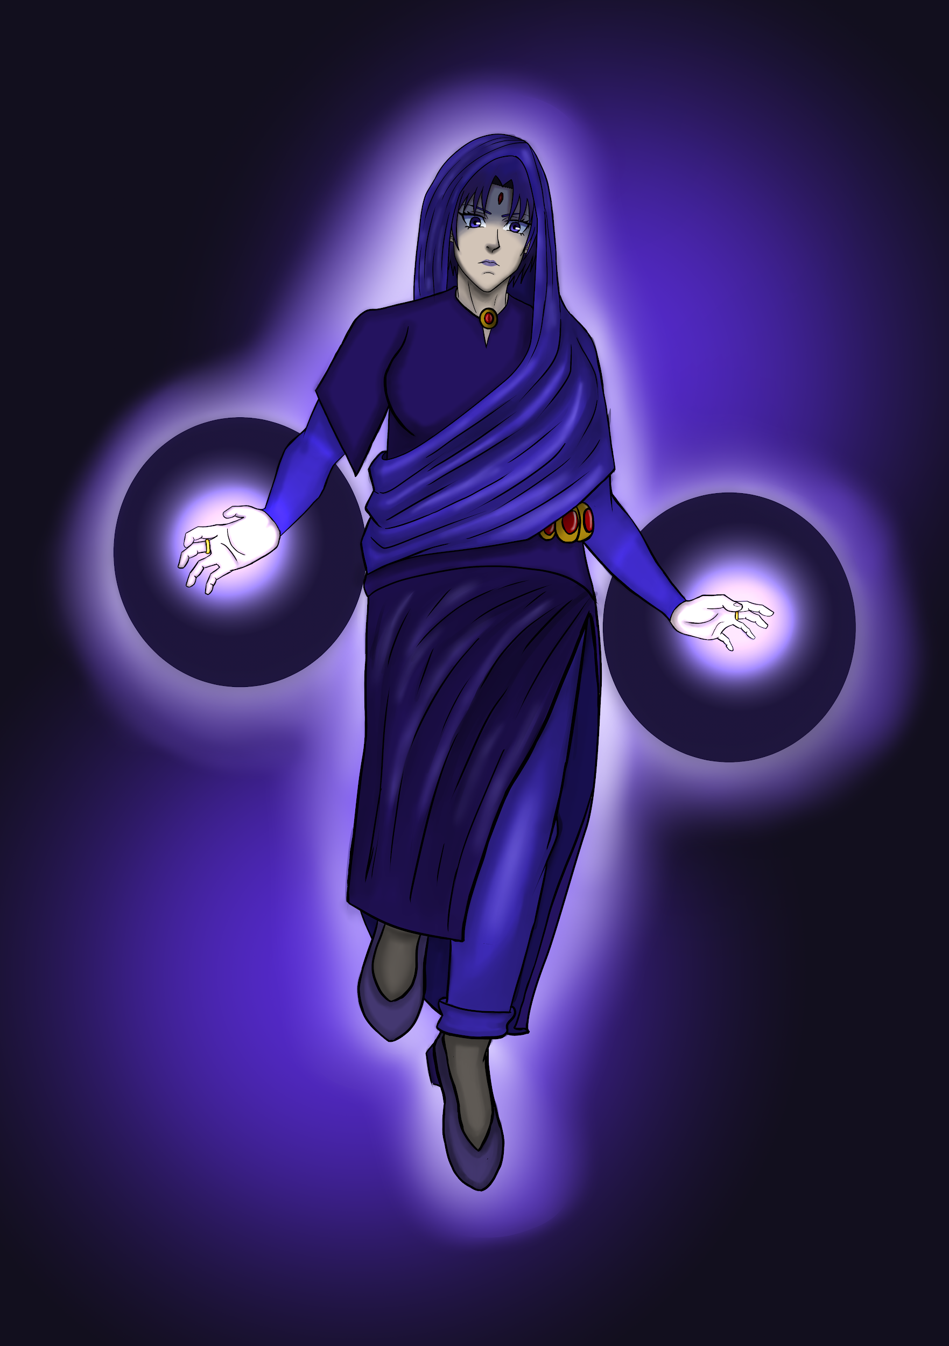

**Title: Adilah Siti Cahaya**

**Description:** A Nusantaran-inspired reinterpretation of DC Comics character, Raven

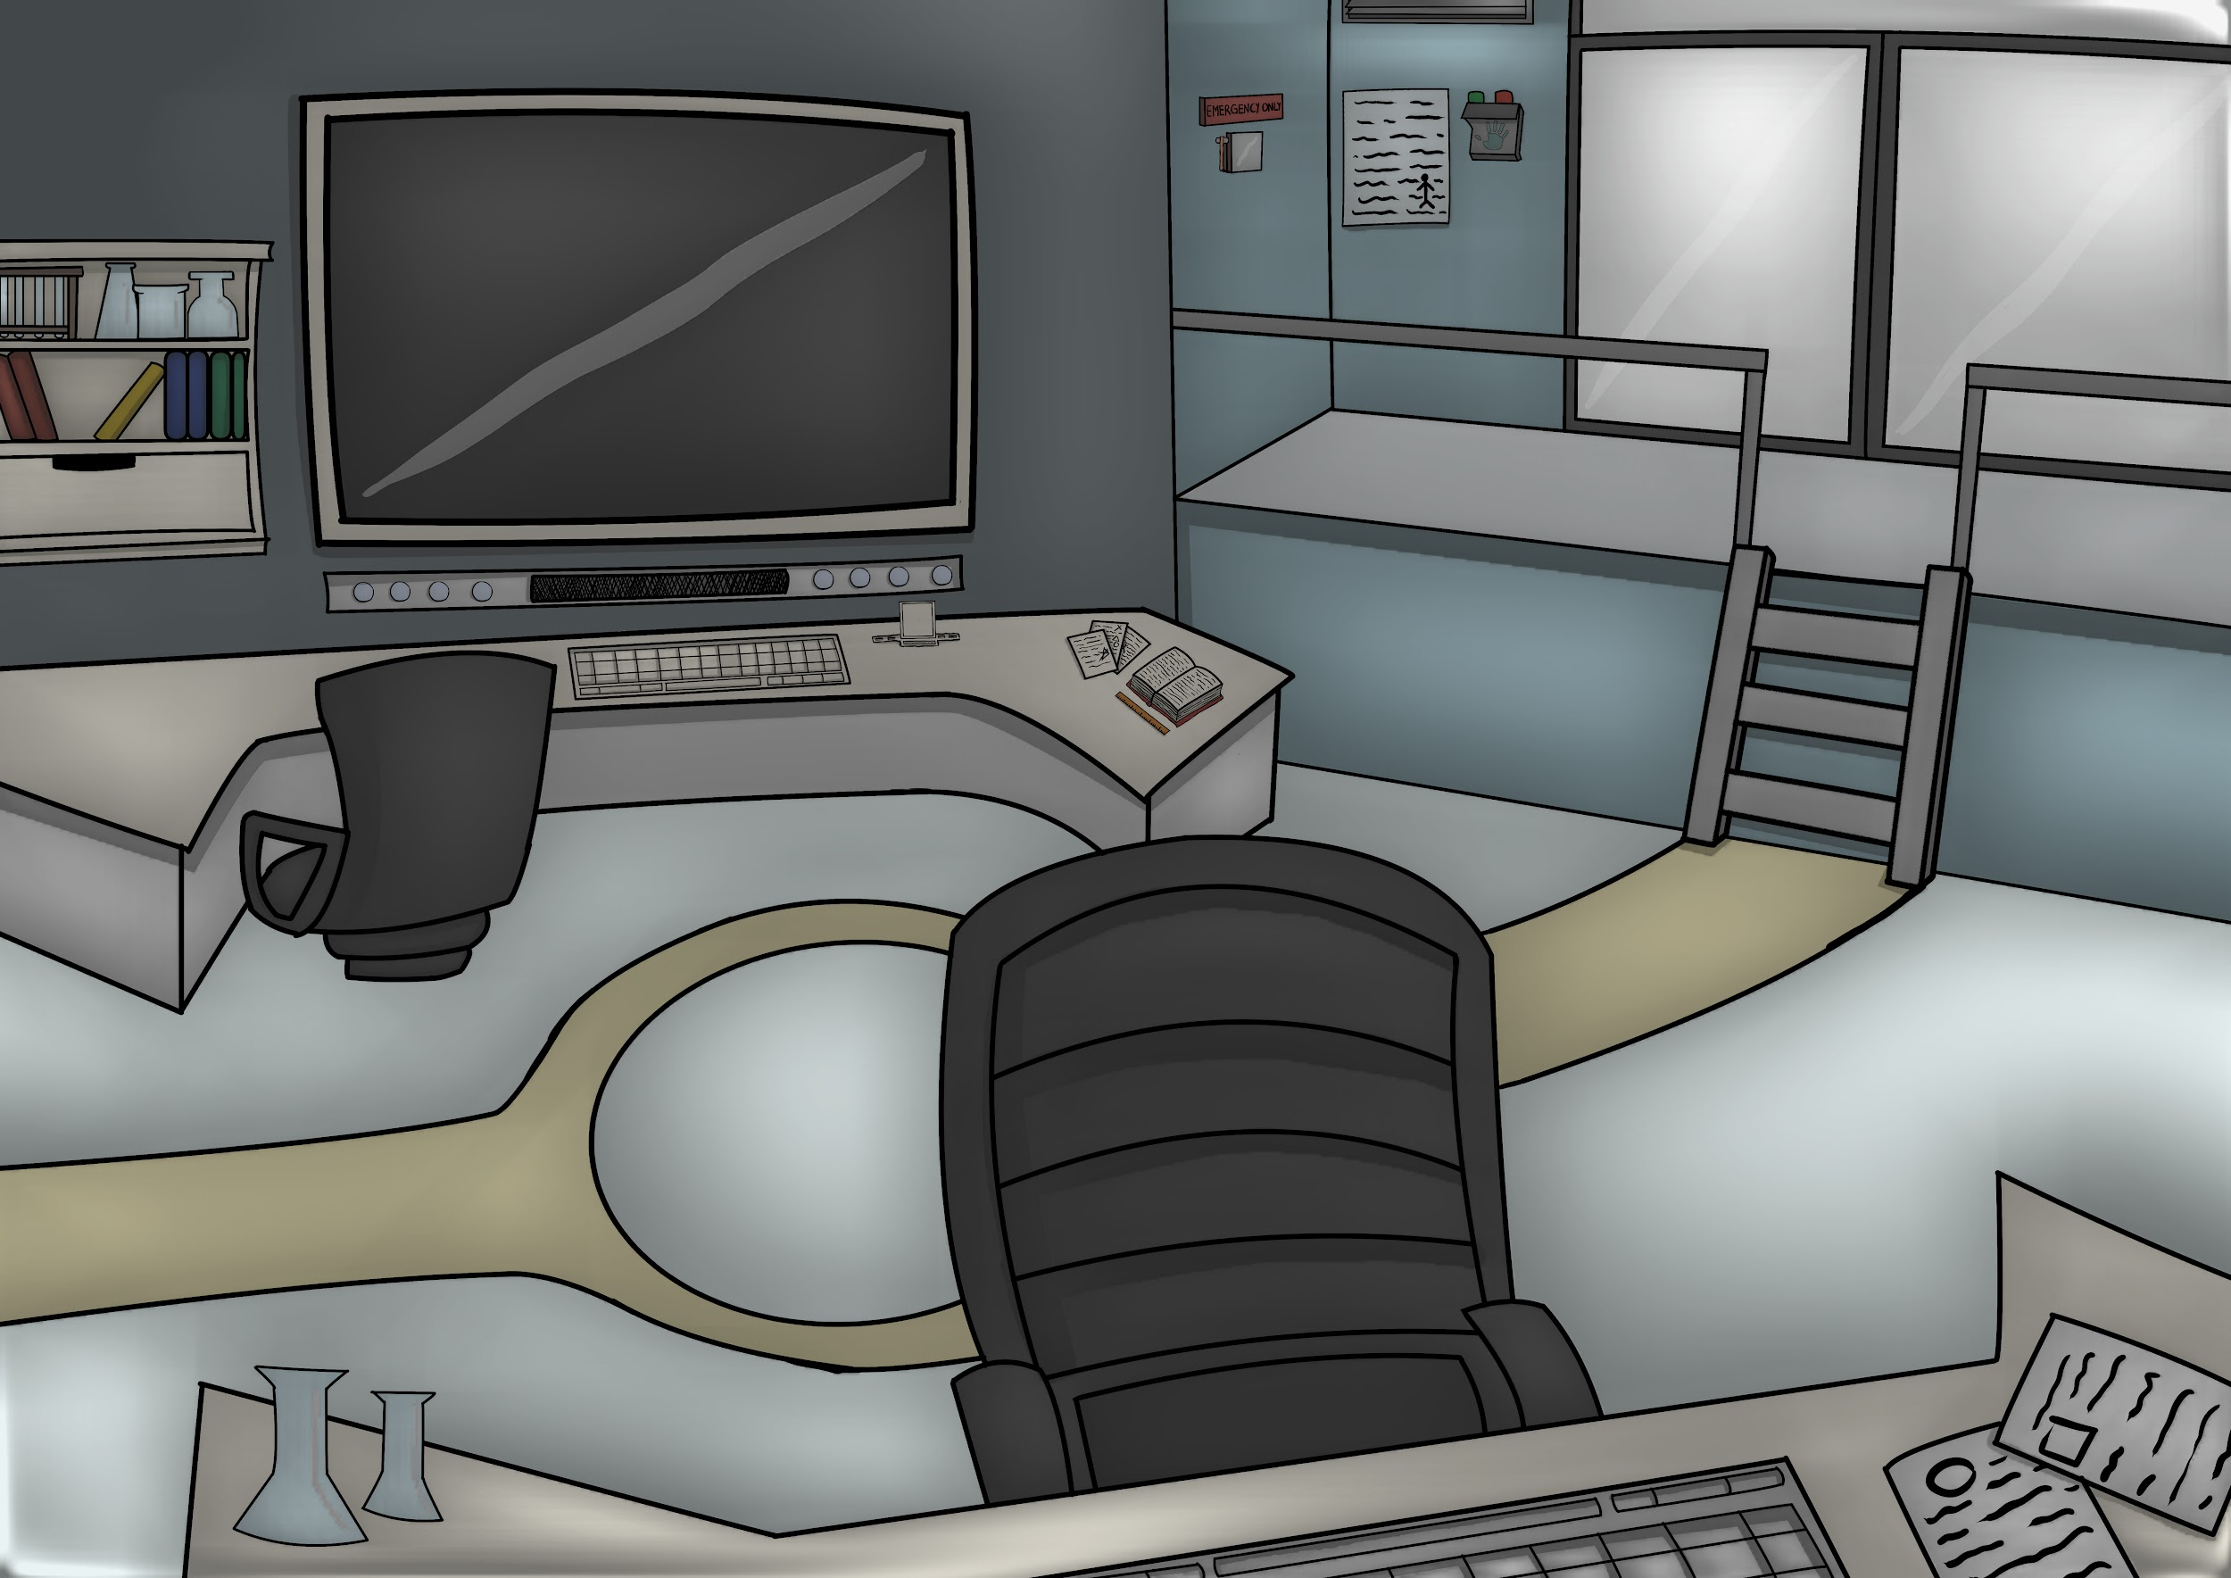

**Title: Moody Science Lab**

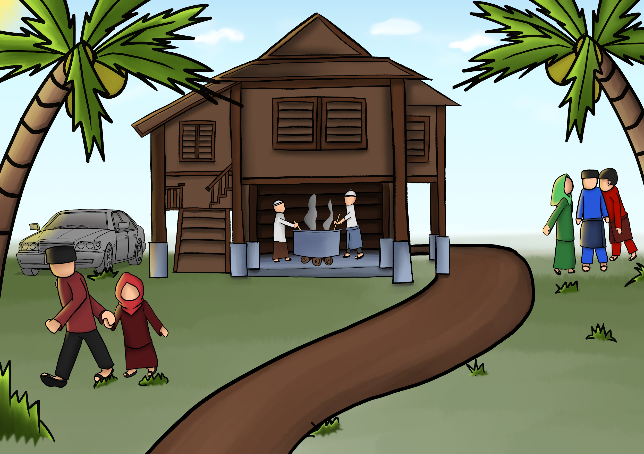

**Title: Hari Raya**



**Title: Malayan Tiger**

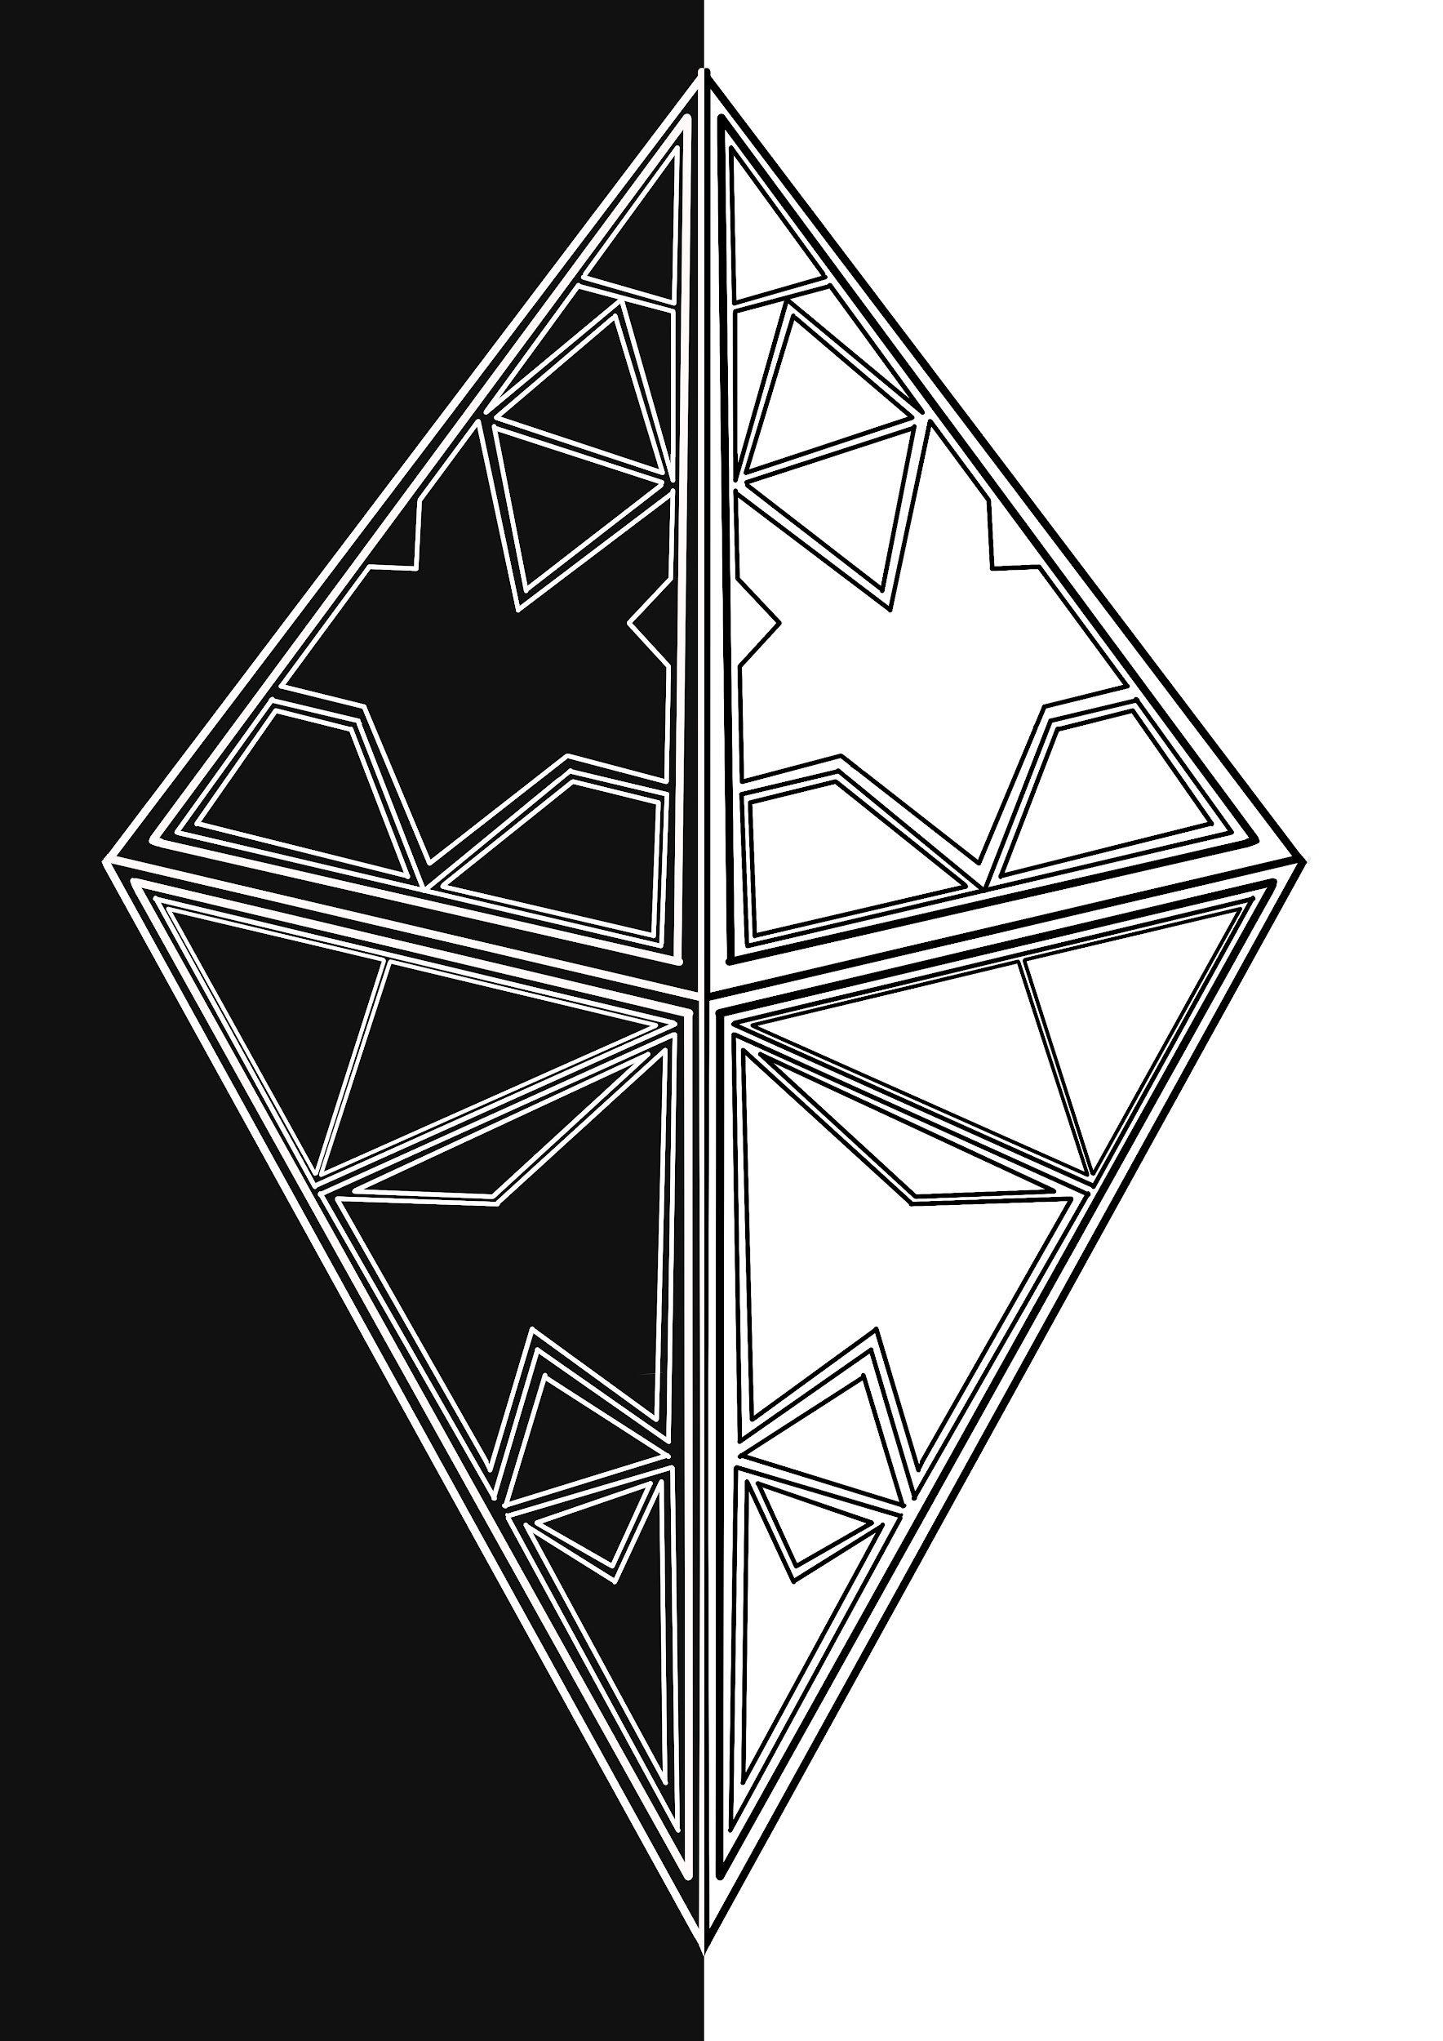

**Title: Contrast and Shapes**

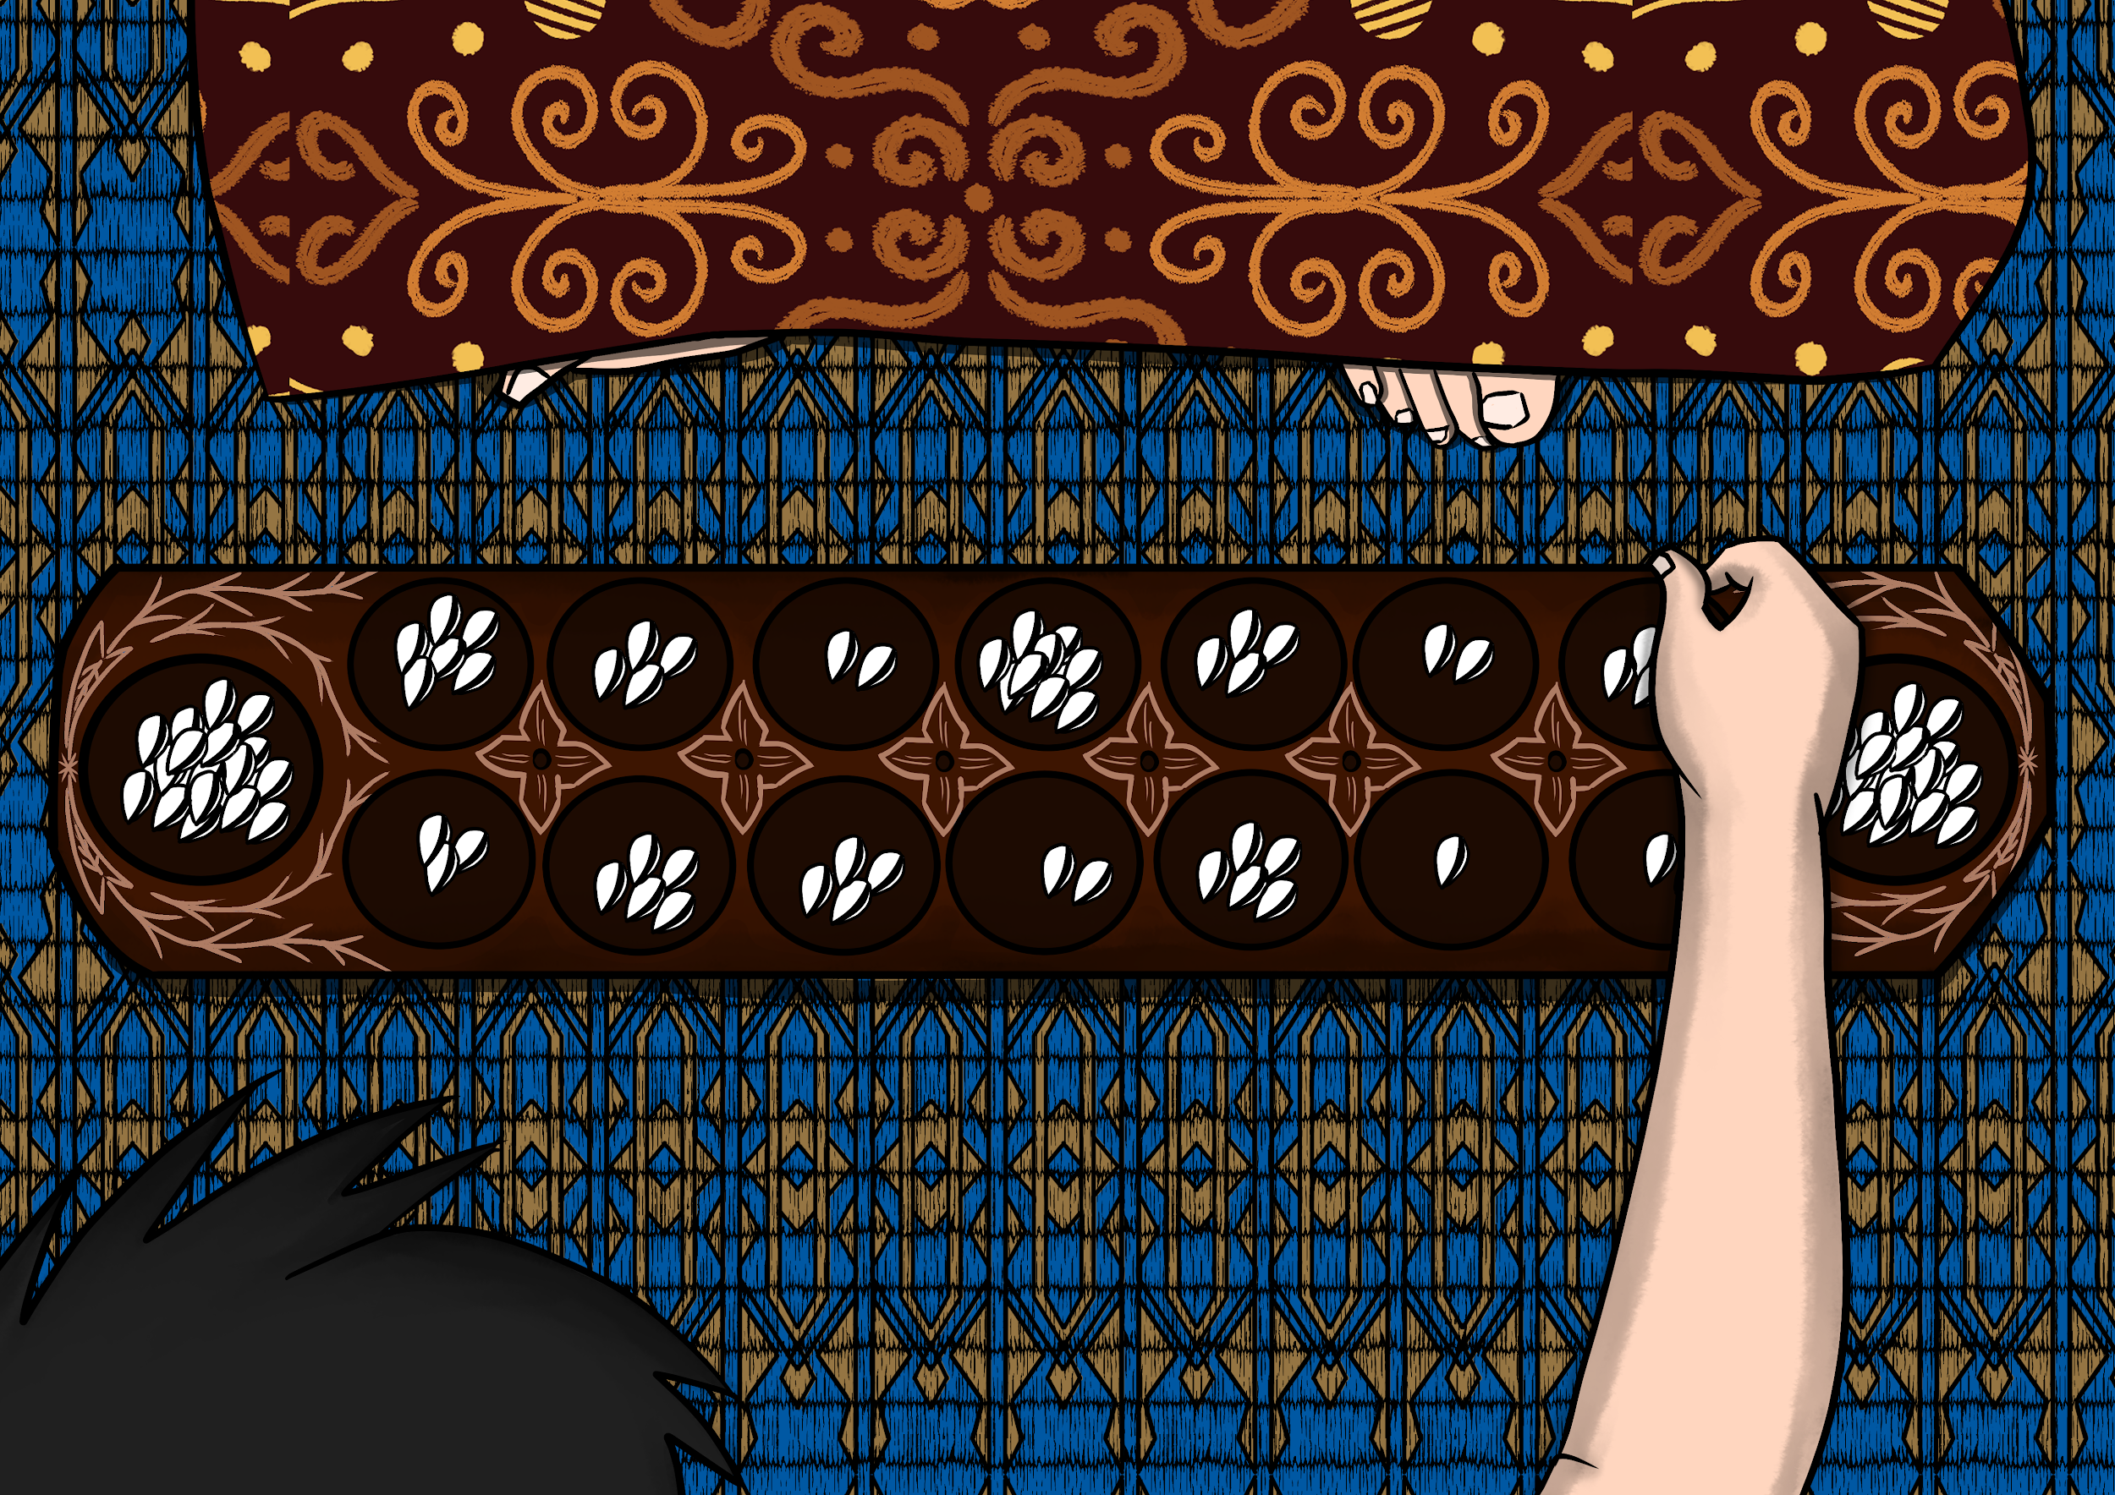

**Title: Congkak**

**Description**: AR art of childhood memory of playing congkak with my late grandmother

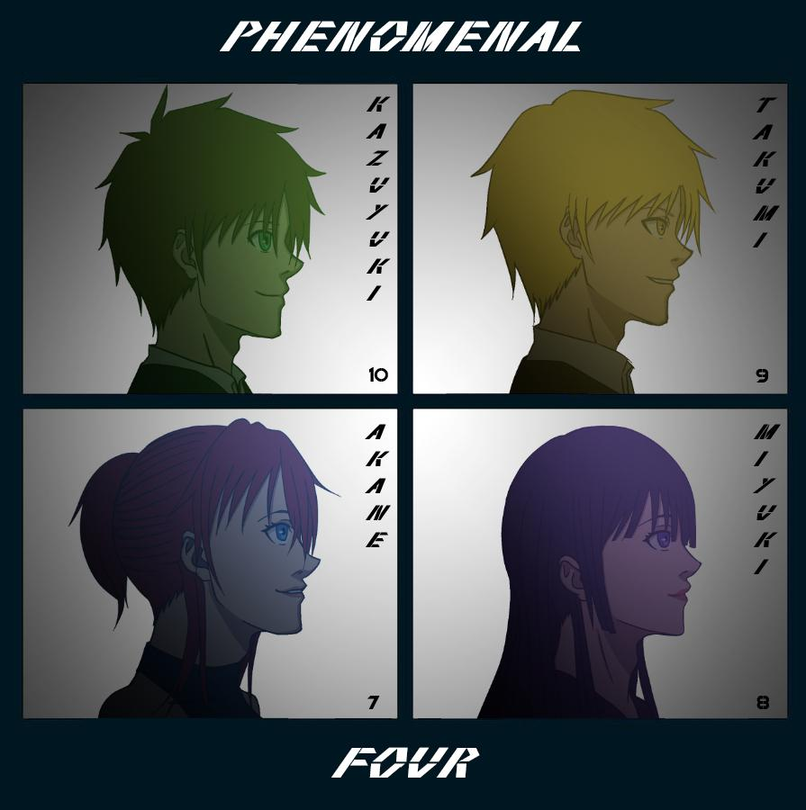

**Title: Phenomenal Four**

**Description:** An artwork featuring my 4 Original Characters inspired from the virtual band Gorillaz’s *Demon Days* album.

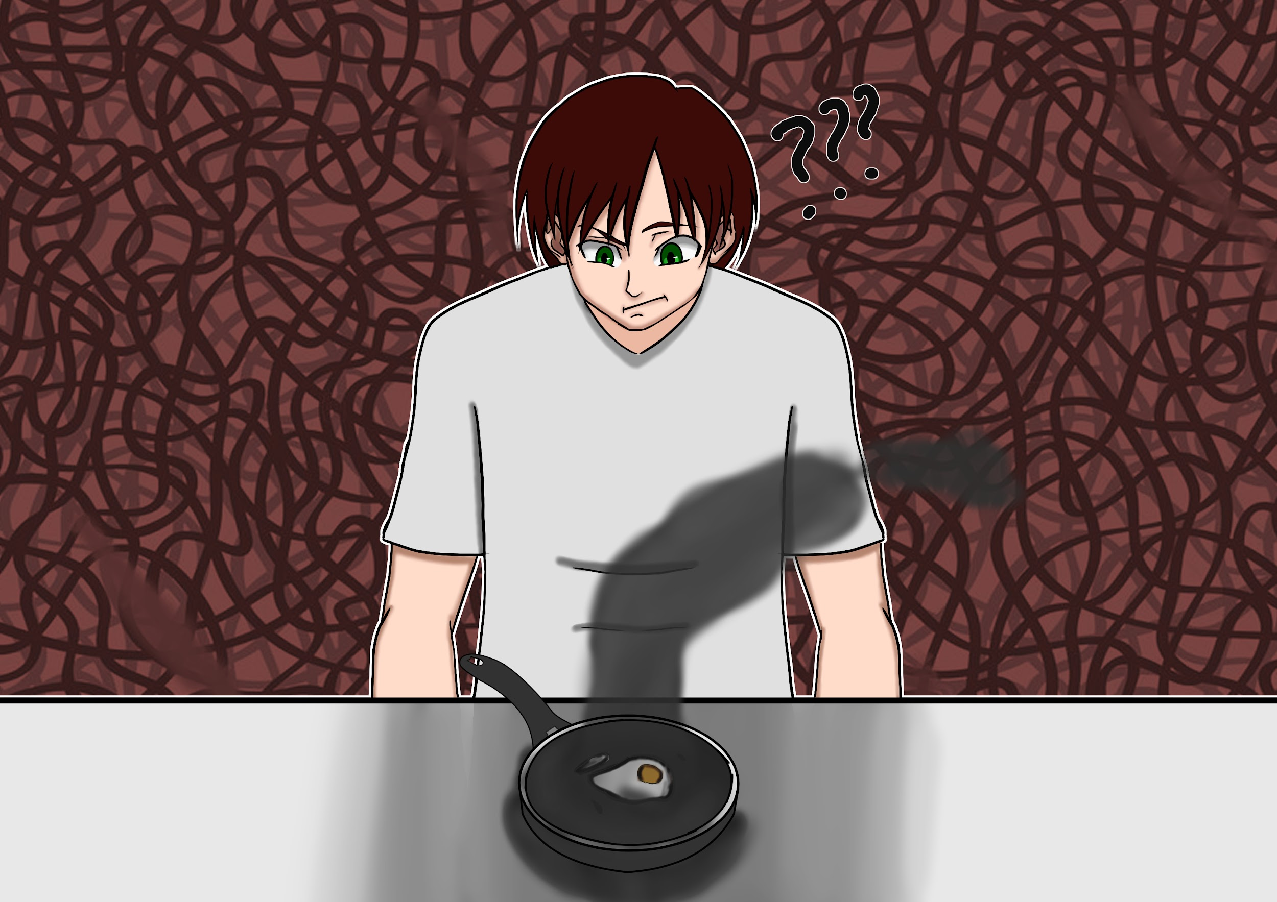

**Title: Breakfast Blunder**

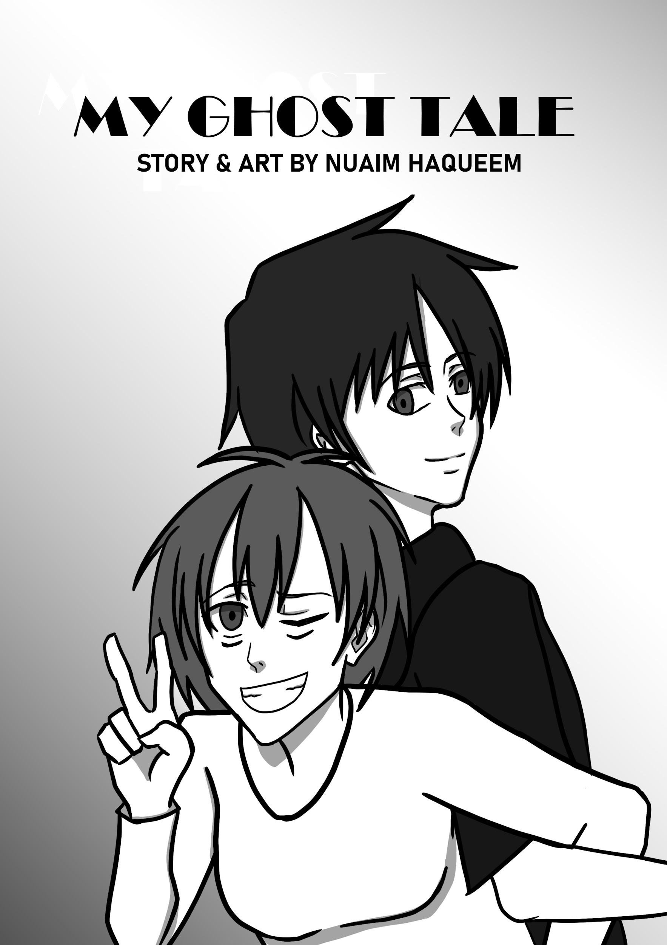

**Title: My Ghost Tale**

**Description**: The cover page of my comic

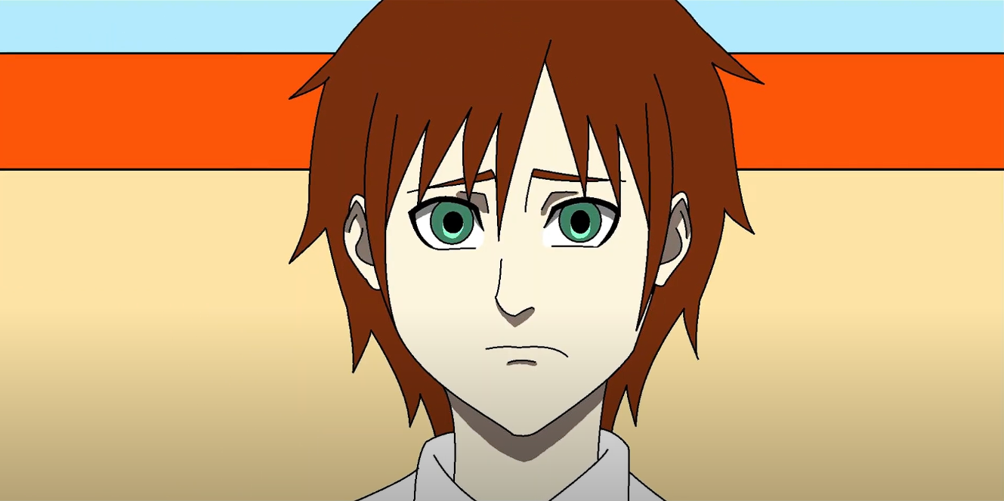

**Title: Redemption**

**Description**: Cover page of my 2D animation Final Year Project during my diploma

**Link:** [**https://youtu.be/ZeGsjbD9yHk?si=MbS39oZcb6Yox5zX**](https://youtu.be/ZeGsjbD9yHk?si=MbS39oZcb6Yox5zX)